Take the Impossible “Literacy” Test Louisiana Gave Black Voters in the 1960s
By Rebecca Onion
This Supreme Court’s decision in Shelby County v. Holder overturned Section 4(b) of the 1965 Voting Rights Act, which mandated federal oversight of changes in voting procedure in jurisdictions that have a history of using a “test or device” to impede enfranchisement. Here is one example of such a test, used in Louisiana in 1964.
After the end of the Civil War, would-be black voters in the South faced an array of disproportionate barriers to enfranchisement. The literacy test—supposedly applicable to both white and black prospective voters who couldn’t prove a certain level of education but in actuality disproportionately administered to black voters—was a classic example of one of these barriers.
The website of the Civil Rights Movement Veterans, which collects materials related to civil rights, hosts a few samples of actual literacy tests used in Alabama, Louisiana, and Mississippi during the 1950s and 1960s.
In many cases, people working within the movement collected these in order to use them in voter education, which is how we ended up with this documentary evidence. Update: This test—a word-processed transcript of an original—was linked to by Jeff Schwartz, who worked with the Congress of Racial Equality in Iberville and Tangipahoa Parishes in the summer of 1964. Schwartz wrote about his encounters with the test in this blog post.
Most of the tests collected here are a battery of trivia questions related to civic procedure and citizenship. (Two from the Alabama test: “Name the attorney general of the United States” and “Can you be imprisoned, under Alabama law, for a debt?”)
But this Louisiana “literacy” test, singular among its fellows, has nothing to do with citizenship. Designed to put the applicant through mental contortions, the test's questions are often confusingly worded. If some of them seem unanswerable, that effect was intentional. The (white) registrar would be the ultimate judge of whether an answer was correct.
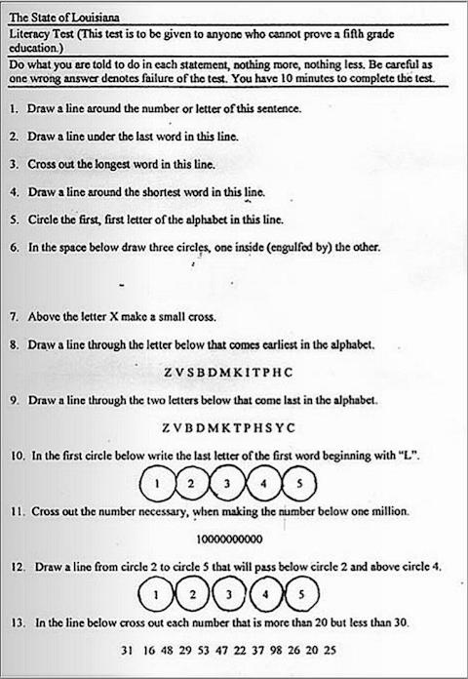
In William Faulkner’s 1938 novel The Unvanquished, the implacable Colonel Sartoris takes drastic action to stop the election of a black Republican candidate to office after the Civil War, destroying the ballots of black voters and shooting two Northern carpetbaggers. While such dramatic means of voter suppression occurred often enough in the Reconstruction South, tactics of electoral exclusion refined over time, such that by the mid-twentieth century the Jim Crow South relied largely on nearly impossible-to-pass literacy tests to impede free and fair elections.
These tests, were “supposedly applicable to both white and black prospective voters who couldn’t prove a certain level of education” (typically up to the fifth grade). Yet they were “in actuality disproportionately administered to black voters.” Additionally, many of the tests were rigged so that registrars could give potential voters an easy or a difficult version, and could score them differently as well. For example, the Veterans of the Civil Rights Movement describes a test administered in Alabama that is so entirely subjective it measures the registrar’s shrewdness and cunning more than anything else.
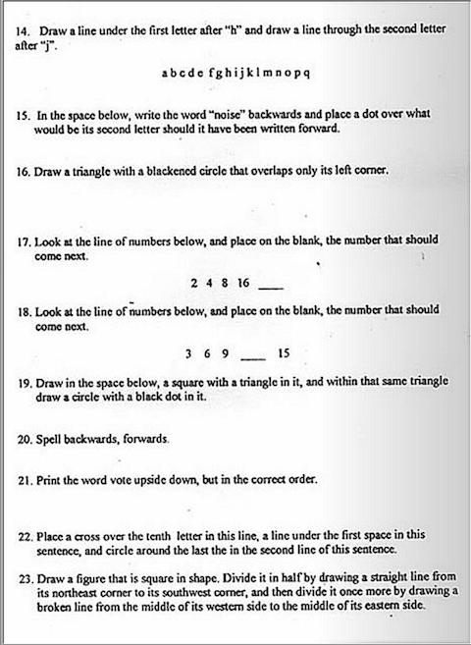

The test here from Louisiana consists of questions so ambiguous that no one, whatever their level of education, can divine a “right” or “wrong” answer to most of them. And yet, as the instructions state, “one wrong answer denotes failure of the test,” an impossible standard for even a legitimate exam. Even worse, voters had only ten minutes to complete the three-page, 30-question document. The Louisiana test dates from 1964, the year before passage of the Voting Rights Act, which effectively put an end to these blatantly discriminatory practices. (Though last year’s Supreme Court decision in Shelby vs. Holder means that such tests, or even more slippery means, could ostensibly return in those parts of the country that have made little progress since the sixties).
